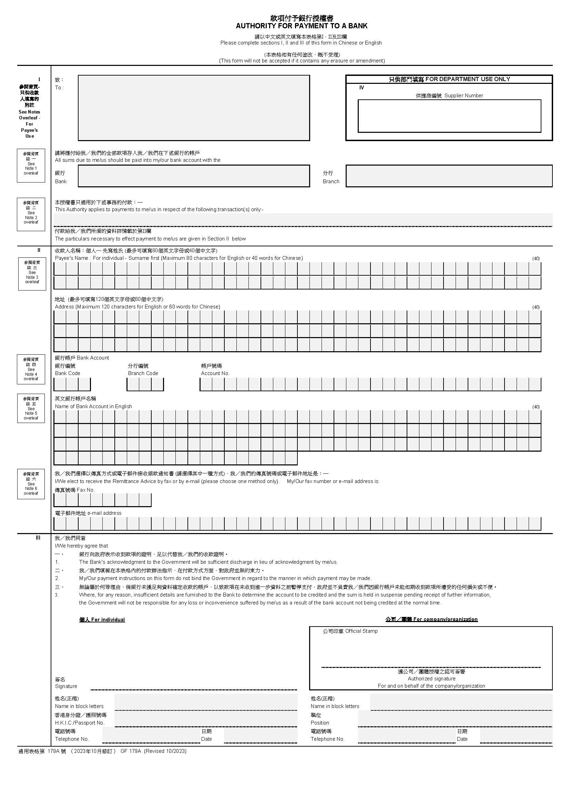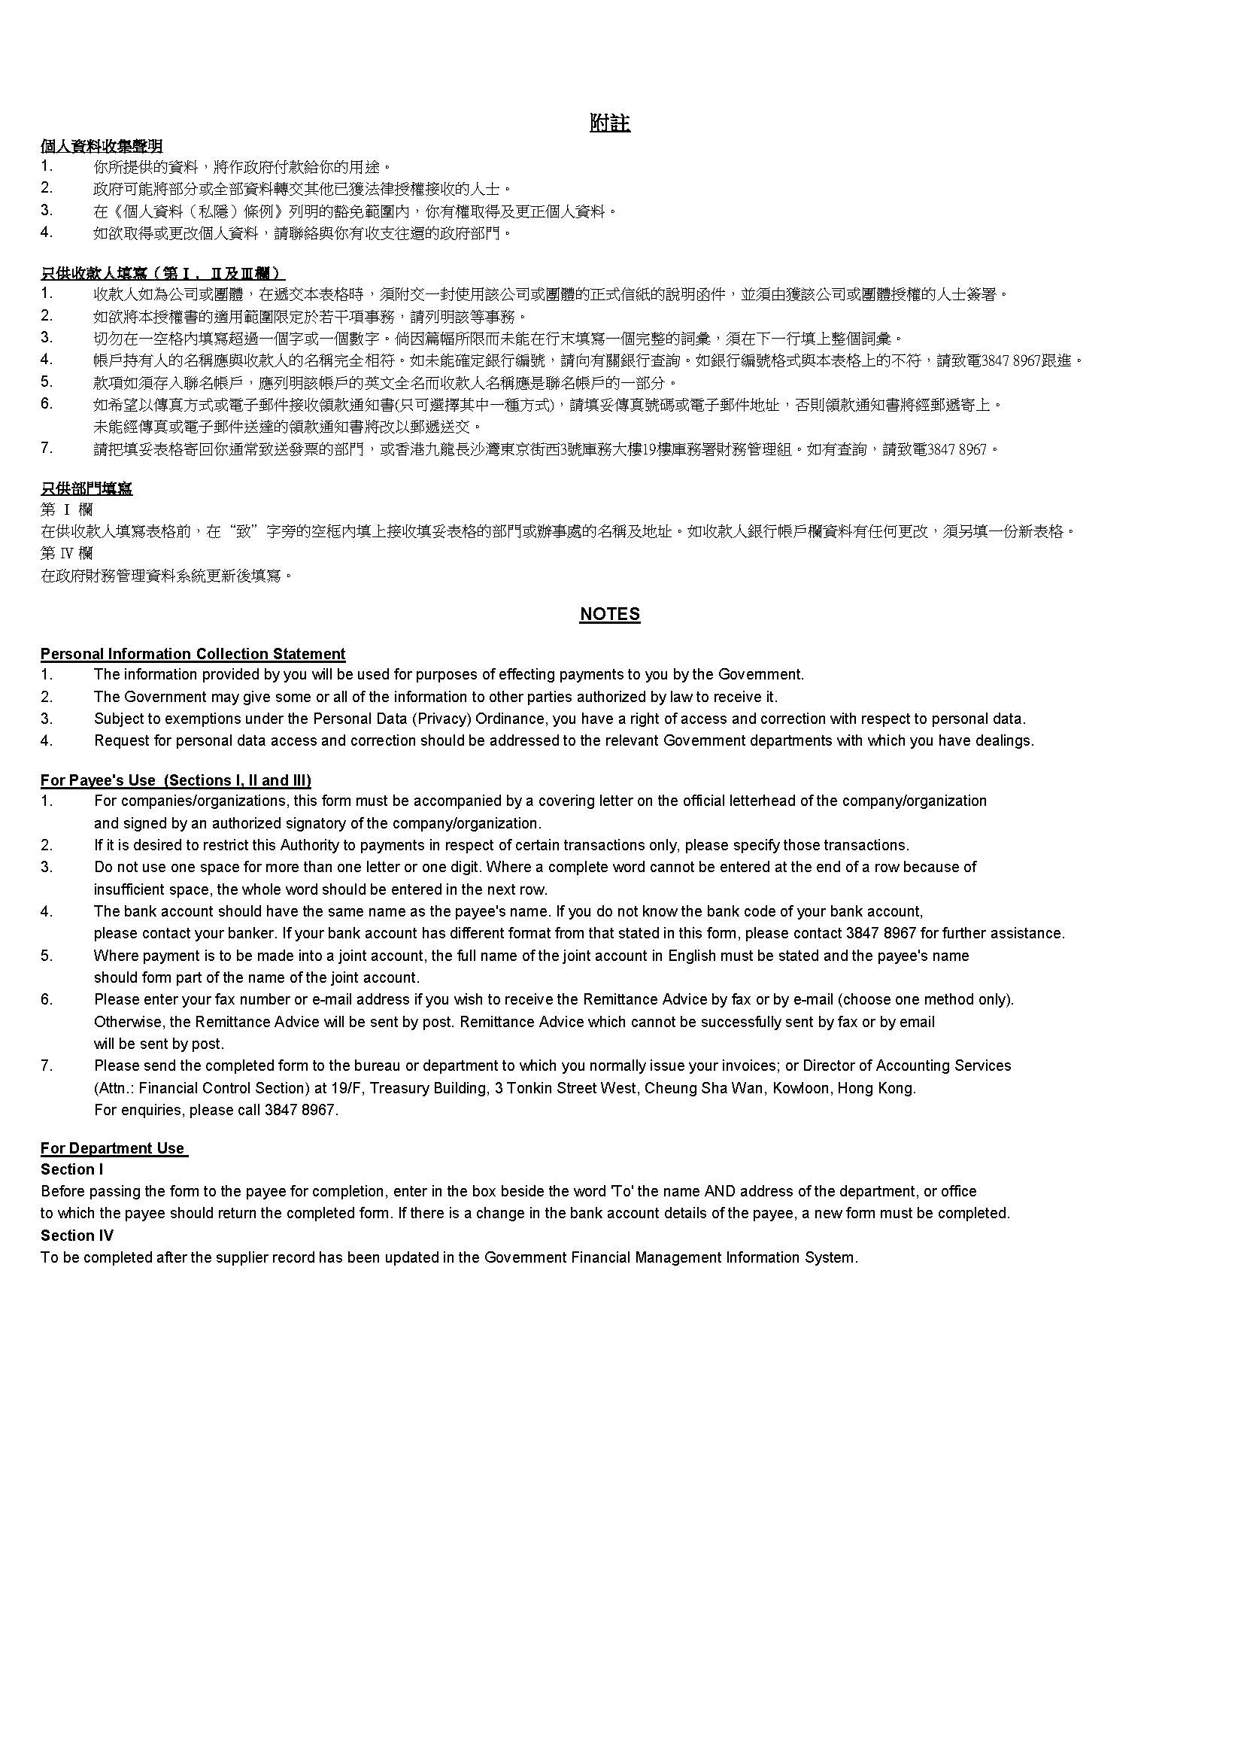

**Employers must submit the form together with hard copy of document with bank account name and number, for example, bank statement or bankbook.**

Payee’s Name **must be the same** as bank account holder name. Abbreviations or aliases would not be accepted. For example, "ABC Engineering Limited" should not be filled in as "ABC ENG Ltd". Any name mismatch with the bank account name would lead to invalid transaction.

Name of organisation/company chop should be the same as the Payee’s Name.

Fill in organisation/company address which is the same as the address shown in Business Registration Certificate.

🗸 are compulsory parts to be completed. If there is amendment, please place chop related to Payee’s Name with the signature of authorized person on amended parts.

Annex 6

🗸

樣本 SAMPLE

🗸

🗸

🗸

🗸

🗸

🗸

🗸

🗸

🗸

🗸