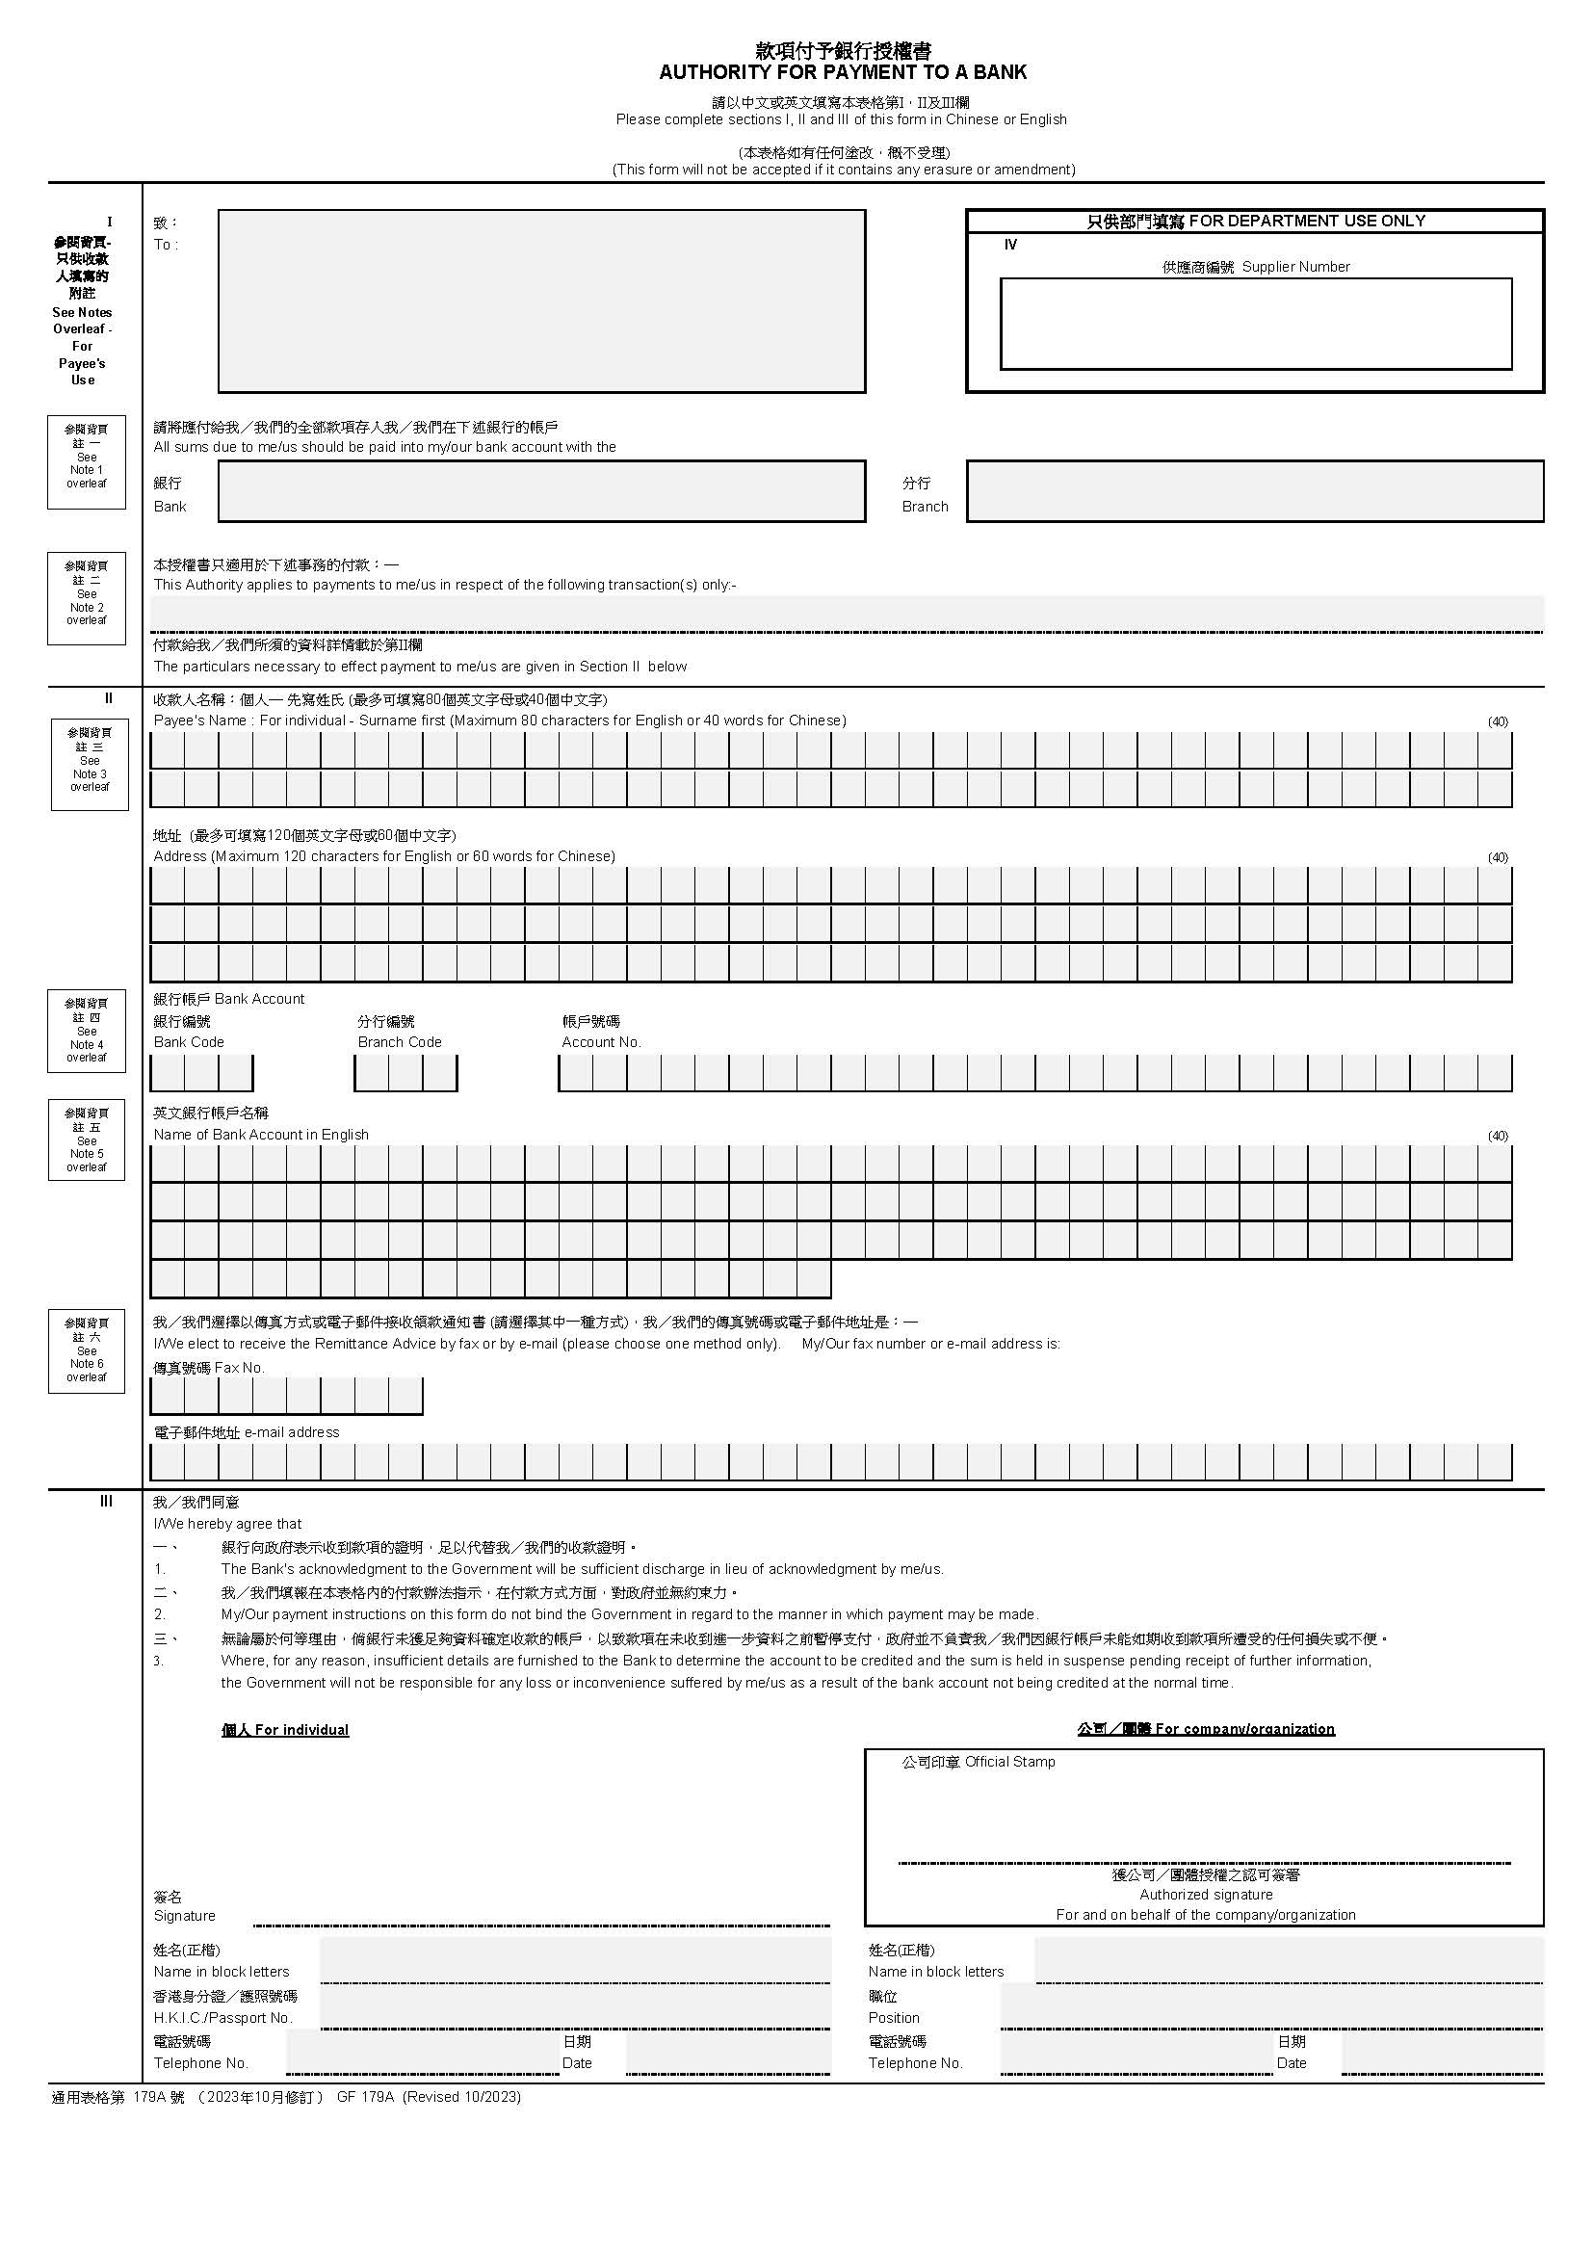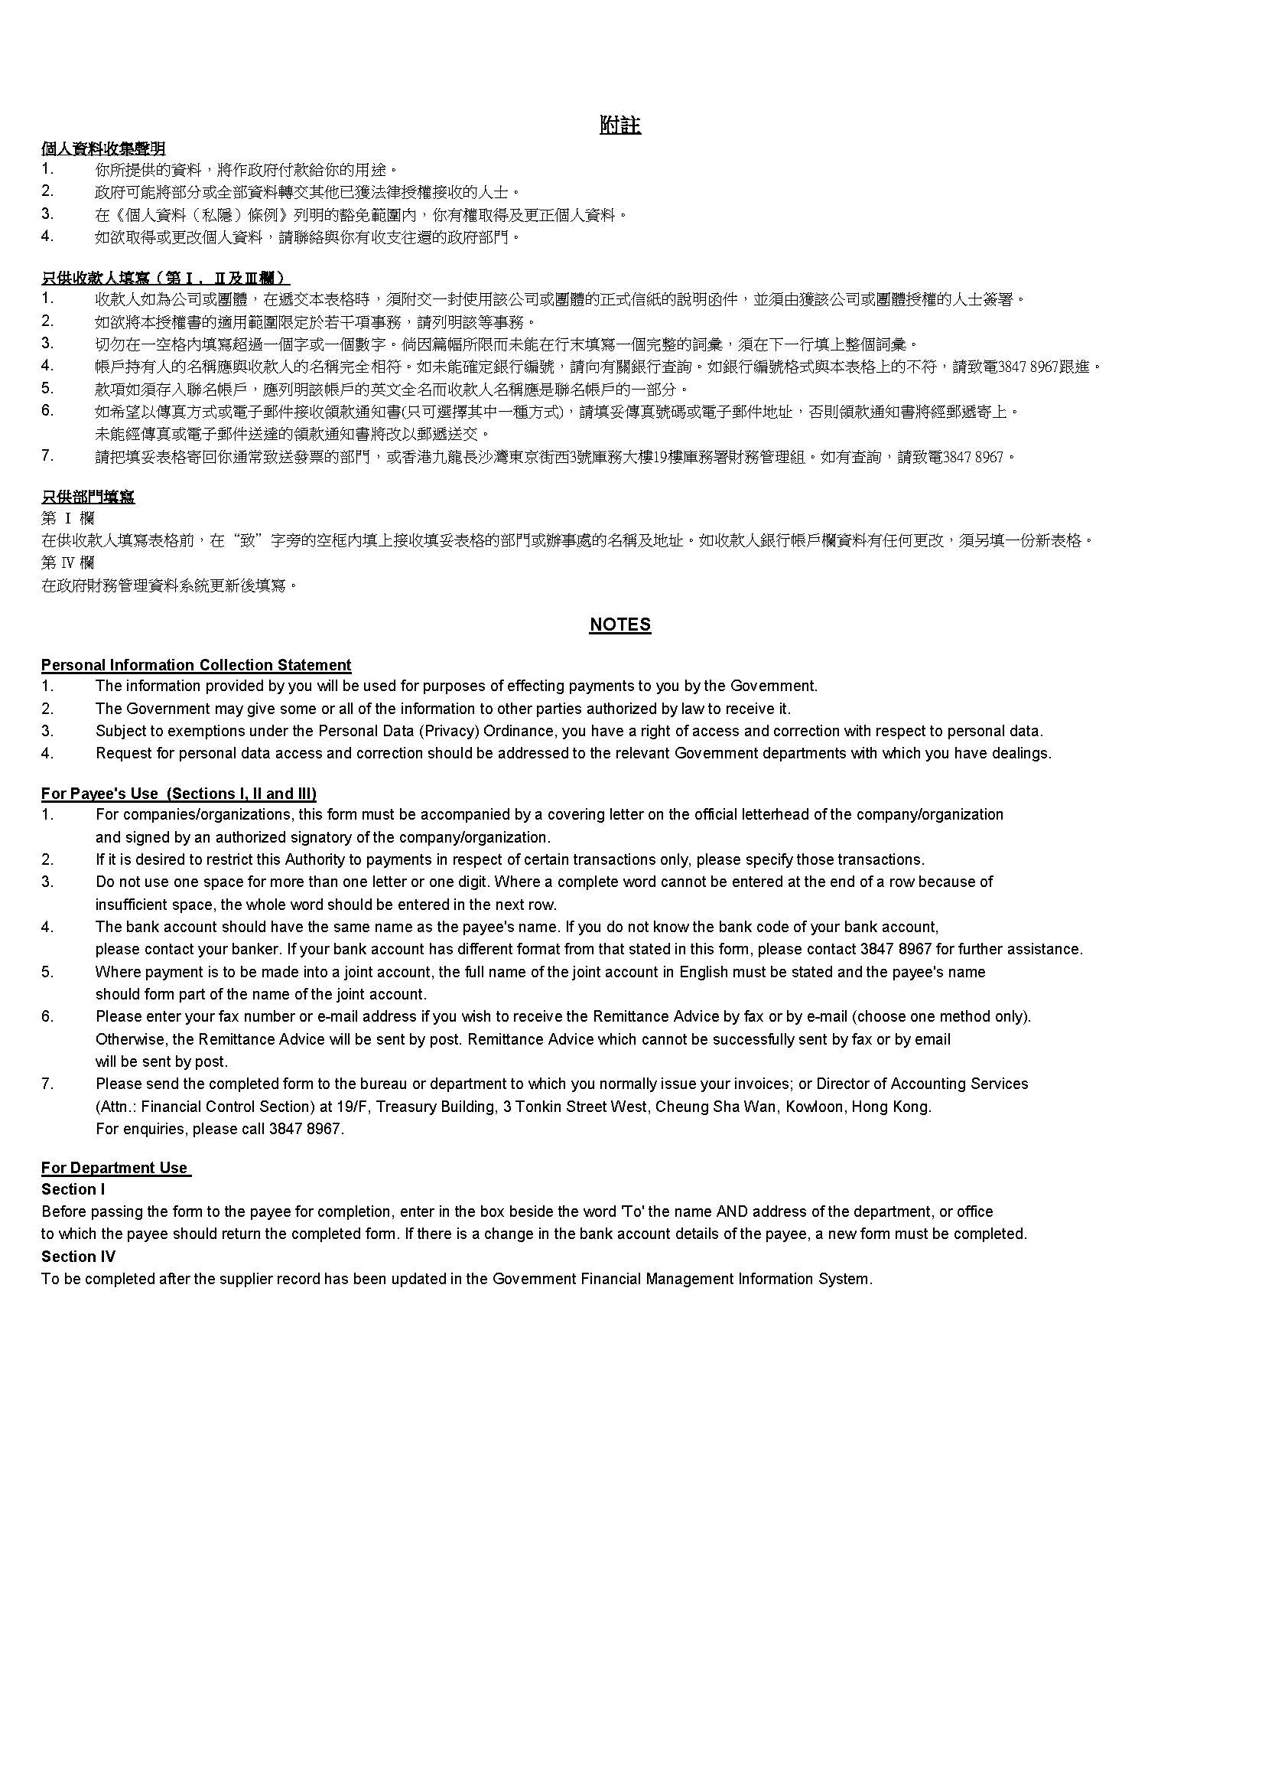

Name of organisation/company chop should be the same as the Payee’s Name.

Fill in organisation/company address which is the same as the address shown in Business Registration Certificate.

🗸 Compulsory parts to be completed. If there is amendment, please place chop related to Payee’s Name with the signature of authorized person on amended parts.

Payee’s Name **should be exactly** the same as bank account holder name. Abbreviations or aliases would not be accepted. Please make reference to your bank statement on the exact Payee’s Name. For example, "ABC Engineering Limited" cannot be filled in as "ABC ENG Ltd". Any name mismatch with the bank account name would lead to invalid transaction.

Annex 6

🗸

樣本 SAMPLE

🗸

🗸

🗸

🗸

🗸

🗸

🗸

🗸

🗸

🗸